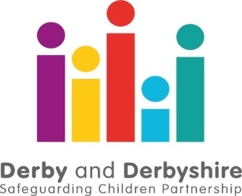

COVID 19 Performance Summary Briefing – Up to 28th February 2021.

The Derby and Derbyshire Safeguarding Children Partnership is working with all agencies involved in safeguarding children and young adults to understand the impact of the COVID19 pandemic and lockdown conditions. This includes where there is an anticipated increase in risks to children and young people because of the current situation, as well as how well agencies are working together to ensure at risk and vulnerable children are safe. So far, we can see that since the first lockdown period began on March 23rd 2020 up until the 28th February 2021…
Contacts from members of the public and professionals concerned about the welfare of a child or young person in the County are lower than the same period last year, whilst those in the City are higher. If you are worried about a child or family, there are details here on how to get help. In an emergency, if you believe a child or adult is at immediate risk of serious harm, you should call 999 straight away and speak to the police.
The proportion of contacts that meet the threshold for social care is similar to those seen pre-lockdown. Work continues across the partnership to understand why some do not meet the threshold and to ensure children and families receive the right help at the right time.
Throughout this period schools were only open to vulnerable children and children of key workers, as a result of the third lockdown. Contacts and referrals from schools remain lower than usual as a result, however schools and other agencies continue to work together to ensure that children are seen and are able to access the services they need.
The high level of domestic abuse calls to the Police seen late last year has reduced; as with previous lockdowns it is anticipated that this will increase again as restrictions are lifted. If you are worried about domestic abuse, there is further information on how you can get help here.
There has been a slight improvement in some of the waiting lists for children and young people waiting to access mental health support along with a fall in the number of children accessing urgent services for eating disorders, and the number of children in mental health inpatient beds. If you would like further information on available support, you can call the Mental Health Support line, details here.
Offences involving a child under 18 (based on age of victim at date of offence) across both the City and County have increased in January and February, although the proportion of these crimes that have a family link has decreased.
We will be reporting bi-monthly to the Chief Officer Group and further briefings will be provided to reflect the changing nature of performance data as a result of the impact of COVID-19.
Further information about local safeguarding processes is available from:

The Derby and Derbyshire Safeguarding Children Partnership Version: 08/03/2021

