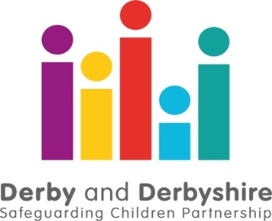

COVID 19 Performance Summary Briefing – Up to 30th September 2020.

The Derby and Derbyshire Safeguarding Children Partnership is working with all agencies involved in safeguarding children and young adults to understand the impact of the COVID19 pandemic and lockdown conditions. This includes where there is an anticipated increase in risks to children and young people because of the current situation, as well as how well agencies are working together to ensure at risk and vulnerable children are safe.

We have been looking at information from all agencies. So far, we can see that since the lockdown period began on March 23rd 2020 up until the 30th September 2020...

Contacts from members of the public and professionals concerned about the welfare of a child or young person and the number of referrals to children’s social care have increased significantly this month compared to August. If you are worried about a child or family, there are details here on how to get help. In an emergency, if you believe a child or adult is at serious risk of immediate harm, you should call 999 straight away and speak to the police.
The top four referral sources for both local authorities are Derbyshire Police, Schools, individuals and health services.

The increase in domestic abuse calls continued, with a higher percentage rise in high and medium risk cases, family abuse and abuse against males. The greatest increases in High Peak, Amber Valley and North East Derbyshire. If you are worried about domestic abuse, there is further information on how you can get help here.
Referrals to Child and Adolescent Mental Health Services (CAMHS) continue to increase after an initial fall and are comparable with the same time last year. The increase in severity of presentation has continued, particularly in attendances at ED. If you would like further information on available support, you can call the Mental Health Support line, details here.
CAHMS Waiting times in some areas remain significantly higher than the corresponding period last year, but there has been improvement in some areas. In the North of the County, the average waiting time is 23 weeks, and 24 in the South of the County including Derby City.
There is limited evidence of any trends in the number of crimes against young people or crime type. In Derby, there has been an apparent increase in the proportion of crimes that have a familial link.
We will be reporting monthly and further briefings will be provided to reflect the changing nature of performance data as a result of the impact of COVID-19. Further information about local safeguarding processes is available from:
The Derby and Derbyshire Safeguarding Children Partnership
Version: 14/10/2020

