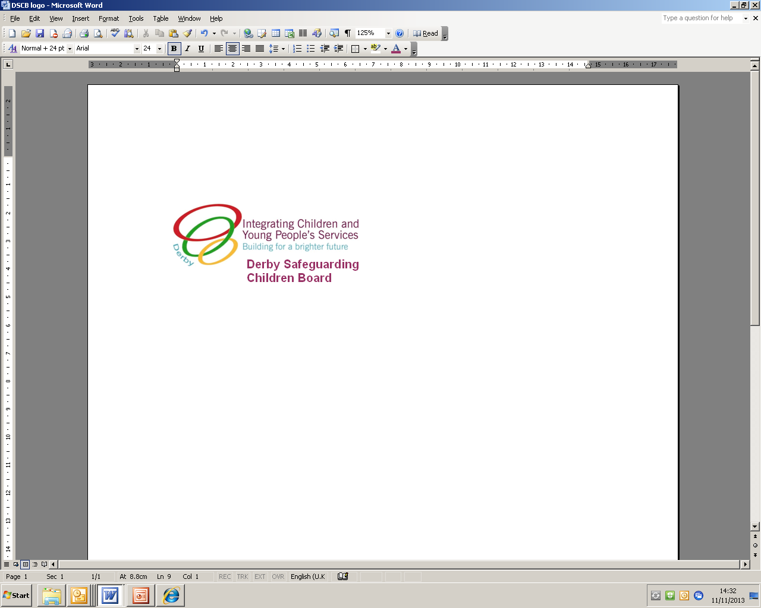

**Derby and Derbyshire Safeguarding Children Boards’**

**Multi-agency report for Review Child Protection Conference (RCPC)**

|  |  |  |  |
| --- | --- | --- | --- |
| **Name/job title of professional completing report:** |  | | |
| **Agency:** |  | | |
| **Workplace address, including postcode:** |  | | |
| **Phone number:** |  | **Email:** |  |
| **Name/job title of manager:** |  | **Email:** |  |
| **Signature:** |  | **Date:** |  |
| **Date of ICPC:** |  | **Date of RCPC:** |  |

**Child/children’s details, including any unborn children** (For any unborn children please insert the mother’s NHS number, when born update the form with the child’s own NHS number)

|  |  |  |  |  |  |  |  |
| --- | --- | --- | --- | --- | --- | --- | --- |
| **Name of child/young person:** | |  | | **Nursery/School and DfE No:** | |  | |
| **EDD/DOB** | **Gender** | | **NHS No.** | | **Ethnicity** | | **Disabilities** |
|  | Female  Male | |  | |  | |  |
| **Name of child/young person:** | |  | | **Nursery/School and DfE No:** | |  | |
| **EDD/DOB** | **Gender** | | **NHS No.** | | **Ethnicity** | | **Disabilities** |
|  | Female  Male | |  | |  | |  |
| **Name of child/young person:** | |  | | **Nursery/School and DfE No:** | |  | |
| **EDD/DOB** | **Gender** | | **NHS No.** | | **Ethnicity** | | **Disabilities** |
|  | Female  Male | |  | |  | |  |
| **Name of child/young person:** | |  | | **Nursery/School and DfE No:** | |  | |
| **EDD/DOB** | **Gender** | | **NHS No.** | | **Ethnicity** | | **Disabilities** |
|  | Female  Male | |  | |  | |  |
| **Name of child/young person:** | |  | | **Nursery/School and DfE No:** | |  | |
| **EDD/DOB** | **Gender** | | **NHS No.** | | **Ethnicity** | | **Disabilities** |
|  | Female  Male | |  | |  | |  |

|  |  |
| --- | --- |
| **Family Home address, including postcode:** | |
|  | |
| **Phone number:** |  |

**Parent/carers details**

|  |  |  |  |  |
| --- | --- | --- | --- | --- |
| **Parent/carer name** | **DOB** | **Address, if different from the above** | **Phone number** | **Relationship to child/children** |
|  |  |  |  |  |
|  |  |  |  |  |
|  |  |  |  |  |

**Details of significant others living or not living in the household**

|  |  |  |  |
| --- | --- | --- | --- |
| **Name** | **DOB** | **Address, if different and phone number** | **Relationship to child/children** |
|  |  |  |  |
|  |  |  |  |
|  |  |  |  |
|  |  |  |  |
|  |  |  |  |

**Key Information for the Review Child Protection Case Conference**

**Impact**

|  |
| --- |
| 1. **What have you accomplished with the unborn/child/children and family since the last child protection conference? What progress has been made against the child protection plan?** (Consider assessments/ interventions with child/parents/carers/family, core groups and communications with partner agencies) |
|  |

|  |
| --- |
| 1. **Who have you seen and when**? (Attendance/non-attendance at appointments, clinics, home visits, core groups etc.) |
| **Child/children:** |
| **Parents/carers:** |

|  |
| --- |
| 1. **Child’s individual wishes and feelings** (Consider what you have observed and/or what the child has told you. What is their understanding about what’s happening to them and why they think agencies are involved? What would they like to see changed?) |
|  |

**ANALYSIS**

**Strengths/Resilience/Safety**

|  |
| --- |
| 1. **What is working well/What has been achieved?** (Consider what has changed and how this impacts on each individual child, including unborn baby) |
|  |

**Threats/Risks**

|  |
| --- |
| 1. **What is still outstanding?** (Re-consider identified or possible risks, change within each child’s timeframe and potential for change) |
|  |

**Opportunity**

|  |
| --- |
| 1. **What will good look like?** (How will you know things are improving for the unborn/child/children? What will be different, what will we see? How will everyone (including the child) be working together and know what is happening? |
|  |

**Partnership/Planning**

|  |  |  |  |
| --- | --- | --- | --- |
| 1. **What will be your continued role in improving the outcomes for the unborn/child/children?** | | | |
|  | | | |
| **What are the unborn/**  **child/children’s needs?** (Desired outcomes) | **How will we meet them?** (Be concrete and specific) | **Who will do it?**  (Family member, extended family, professional, other) | **When will this be done?** (Remember child’s time frames) |
|  |  |  |  |
|  |  |  |  |
|  |  |  |  |
|  |  |  |  |
|  |  |  |  |
| **What are your fears if the agreed actions are not completed and things don’t improve for the unborn/child/children?** | | | |

**Participation**

|  |
| --- |
| 1. **With whom have you shared your report? If not shared, why not?** |
|  |
| **Where appropriate, child’s/young person’s comment on report and recommendations:** |
| **Parents/carers comment on report and recommendations:** |

**END**